 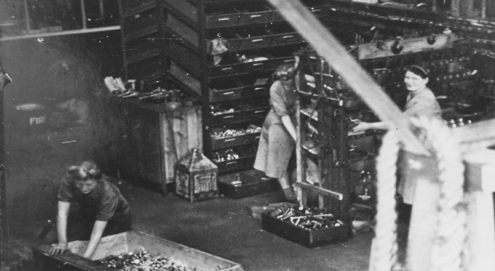

**A Woman’s work …**

Women working at Grosvenor Garage in

Burnage maintaining Merlin engines during ww2

**In celebration of International Women’s Week in 6th – 12th March Burnage Memory Bank will be gathering women’s memories of their working lives. Stories will be displayed in the Library over March. Use the questions to start you off and write as much or as little as you like! If you have any photos – we’d love to see them! Talk to Amanda Wait or John McCrory or email** [**amandawait4@gmail.com**](mailto:amandawait4@gmail.com) **for more information. We’d love you to tell us:**

* **What was your first job and where was it? How old were you? How did you get the job? What was your first day like?**
* **Do you remember your first pay packet? How much was it and how did you spend it?**
* **What did you do in your job? What sort of tasks did it involve? What did you like about it? What didn’t you like about it? What were your workmates like?**
* **How long did you work there? What made you leave? What other jobs did you do in your life? Which job suited you the best and why?**
* **What job did you want to do when you were growing up? Did you get to do it?**
* **Do you think things have changed for women today?**

Please continue on the reverse, and use as many sheets of paper as you need.

Don’t worry about handwriting!Displaying FOBLHalo.png